29.46: a) 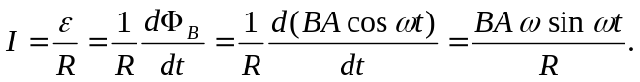
b) 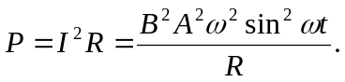
c) 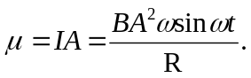
d) 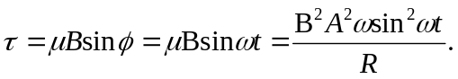
e) 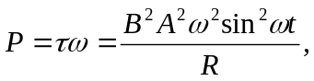 which is the same as part (b).

